Nicoleta Radu

Matlab, tema

# Desen

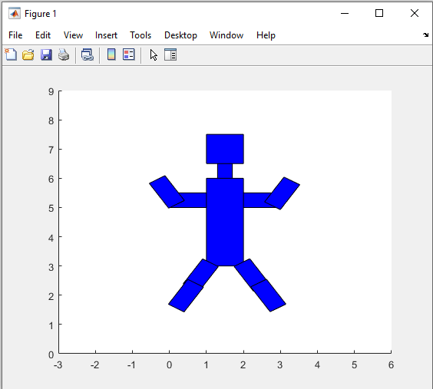

# Functii

function [newCoordonates] = scale(coordonates, scaleAmountXAxis, scaleAmountYAxis)

% Input argument represents a 2x5 matrix containing X and Y coordinates

% Second input argument represents the value by which the polygon will be

% scaled up to

transform = [scaleAmountXAxis 0 ; 0 scaleAmountYAxis];

newCoordonates = transform * coordonates;

% plotting of the newly scaled polygon

% hold on

% plot(newCoordonates(1,:),newCoordonates(2,:),"k")

% axis([0,10,0,10])

end

function [newCoordonates] = rotate(coordonates,degree)

% Input argument represent a 2x5 matrix containing the coordonates

% The polygon will be rotated based on the given degree value

x = coordonates(1,:) * cos(degree) - coordonates(2,:) * sin(degree);

y = coordonates(1,:) * sin(degree) + coordonates(2,:) * cos(degree);

newCoordonates = [x ; y];

% hold on

% plot(x,y,"k")

% axis([0,10,0,10])

end

function [newCoordonates] = translation(coordonates, translateValueX,translateValueY)

% Input argument represents a 2x5 matrix containing the coordonates

% Output represents the new coordonates matrix after translation

transform = [translateValueX ; translateValueY];

newCoordonates = transform + coordonates;

hold on

% plot(newCoordonates(1,:),newCoordonates(2,:),"k")

% axis([0,10,0,10])

end

# Programul Principal

robotBody = [1 1 2 2 1; 1 2 2 1 1];

robotBody = scale(robotBody,1,3);

robotNeck = [1.3 1.3 1.7 1.7 1.3; 6 6.5 6.5 6 6];

robotHead = [1 1 2 2 1; 6.5 7.5 7.5 6.5 6.5];

robotLeftArm = [0 0 1 1 0; 5 5.5 5.5 5 5];

robotLeftHand = rotate(robotLeftArm,-45);

robotLeftHand = translation(robotLeftHand,-4.8,3.2);

robotRightArm = translation(robotLeftArm,2,0);

robotRightHand = rotate(robotRightArm,45);

robotRightHand = translation(robotRightHand,6.2,0.6);

robotLeftLeg = translation(robotRightHand,-2.2,-2.8);

robotLeftFoot = translation(robotLeftLeg,-0.4,-0.7);

robotRightLeg = rotate(robotLeftLeg,-90);

robotRightLeg = translation(robotRightLeg,0.2,4.65);

robotRightFoot = translation(robotRightLeg,0.45,-0.7)

hold on

plot(robotBody(1,:),robotBody(2,:),"k")

fill(robotBody(1,1:end-1),robotBody(2,1:end-1),"b")

plot(robotNeck(1,:),robotNeck(2,:),"k")

fill(robotNeck(1,1:end-1),robotNeck(2,1:end-1),"b")

plot(robotHead(1,:),robotHead(2,:),"k")

fill(robotHead(1,1:end-1),robotHead(2,1:end-1),"b")

plot(robotLeftArm(1,:),robotLeftArm(2,:),"k")

fill(robotLeftArm(1,1:end-1),robotLeftArm(2,1:end-1),"b")

plot(robotLeftHand(1,:),robotLeftHand(2,:),"k")

fill(robotLeftHand(1,1:end-1),robotLeftHand(2,1:end-1),"b")

plot(robotRightArm(1,:),robotRightArm(2,:),"k")

fill(robotRightArm(1,1:end-1),robotRightArm(2,1:end-1),"b")

plot(robotRightHand(1,:),robotRightHand(2,:),"k")

fill(robotRightHand(1,1:end-1),robotRightHand(2,1:end-1),"b")

plot(robotLeftLeg(1,:),robotLeftLeg(2,:),"k")

fill(robotLeftLeg(1,1:end-1),robotLeftLeg(2,1:end-1),"b")

plot(robotLeftFoot(1,:),robotLeftFoot(2,:),"k")

fill(robotLeftFoot(1,1:end-1),robotLeftFoot(2,1:end-1),"b")

plot(robotRightLeg(1,:),robotRightLeg(2,:),"k")

fill(robotRightLeg(1,1:end-1),robotRightLeg(2,1:end-1),"b")

plot(robotRightFoot(1,:),robotRightFoot(2,:),"k")

fill(robotRightFoot(1,1:end-1),robotRightFoot(2,1:end-1),"b")

axis([-3,6,0,9])